2024 Salmon Unlimited Jackpot Series
1. ELIGIBILITY, ENTRY FEE, AND REQUIREMENTS
a. This tournament is only open to Salmon Unlimited of Wisconsin participants. All anglers on each boat must be current Salmon Unlimited of Wisconsin to participate.
b. Entry fee
- $250.00 per boat for the series. Allows the team to compete in all four events and be eligible for the end of year series top three and fish of the year.
c. All applications and payments must be received no later than 6:00 PM May 17th for the first event and 6:00 PM June 7th for the series.
- You may enter the series after the first event and before the second. You will pay the full $250.00 price for the series and the first event will automatically be your dropped score. You will be eligible to compete in events two, three and four and for all prizes associated with series and fish of the year.
d. Entry fees for the series are non-refundable after the conclusion of the first tournament. Any refunds will be made by mail via check after the cancelation of the series if applicable.
e. Every boat must be equipped with an operating VHF marine radio that can transmit and receive channels 16 and 68. All boats should monitor channel 68 for contest information.
f. All participants will compete in one, open division.
g. A boat identification number will be provided at the captains meeting and must be displayed on the Starboard side of the participant’s boat during the contest.
h. All entrants will be required to provide at least one of the following forms of contact to be used for updates and communications regarding the tournament. These contacts will only be used for official tournament business and will not be provided to any other organization or person for any purpose.
- Phone number capable of receiving text messages (preferred)
- E-mail
- Phone number capable of receiving voice call.
2. DATES AND HOURS
Tournaments will be held on the following:
- May 18th, 2024
- June 8th, 2024
- August 10th, 2024
- August 24th, 2024
Rain Dates
Each tournament will have a rain date that is always the next day (Sunday) and are as follows:
- May 19th, 2024
- June 9th, 2024
- August 11th, 2024
- August 25th, 2024
If the associated Sunday rain date does not work, there are two last chance rain dates which can be used for any of the four events. If required both September 7th and 8th will be used.
- September 7th, 2024
- September 8th, 2024
The tournament schedule will be as follows:
a. Captain’s Meetings. There will be an in person and virtual option for each captains meeting. All captains meetings will be the day before the scheduled tournament date. The location will be the Pershing Park Boat Launch Pavilion. 1 5th St, Racine, WI 53403. Virtual will be via the Jackpot Challenge Series by Salmon Unlimited of Wisconsin Facebook page.
Each crew must have at least one member in attendance at the Captain’s Meeting or virtually attend.
- May 17th, 2024. 6:00 PM
- June 7th, 2024. 6:00 PM
- August 9th, 6:00 PM
- August 23rd, 2024. 6:00 PM
- September 6th, 2024. 6:00 PM. Last Chance Rain Date #1
- September 7th, 2024. 6:00 PM. Last Chance Rain Date #2
c. Fishing Periods. (Rain dates for each event will have the same times.)
- May 18th, 2024. 5:00 AM – 1:00 PM
- June 8th, 2024. 5:00 AM – 1:00 PM
- August 10th, 2024. 5:30 AM – 1:30 PM
- August 24th, 2024. 5:30 AM – 1:30 PM
- September 7th, 2024. 6:00 AM – 2:00 PM. Last Chance Rain Date #1
- September 8th, 2024. 6:00 AM – 2:00 PM. Last Chance Rain Date #2
d. The contest will be considered official if a total of three (3) hours are fished.
3. START AND FINISH
a. All boats must start from and return to Racine by water.
b. Check in will begin at approximately the following for each event.
- May 18th, 2024. 4:15 AM
- June 8th, 2024. 4:15 AM
- August 10th, 2024. 4:45 AM
- August 24th, 2024. 4:45 AM
- September 7th, 2024. 5:15 AM. Last Chance Rain Date #1
- September 8th, 2024. 5:15 AM. Last Chance Rain Date #2
The Tournament Committee Boat will check-in all boats by visual and/or VHF radio (Channel 68). All boats will be subject to a random cooler check before or during check in.
c. Run Time. There will be a shotgun start as soon as all boats are checked in approximately 30 minutes before the start time of each tournament. The official run time start will be announced by Tournament Control on VHF channel 68.
d. The official start of the fishing period will be announced by Tournament Control at the start times listed section 2C on VHF channel 68.
e. No lines may be placed in the water before the start announcement and times in section 2C. You are on your honor.
f. By the end of the fishing period each boat must within the check in area. The check in area is defined as West of the green can and no further North than the main harbor entrance and West of the green can and no further South than a line from the green can East to shore. Boats that do not arrive by the time listed in section 2C will be disqualified, no exceptions. See Image 1.
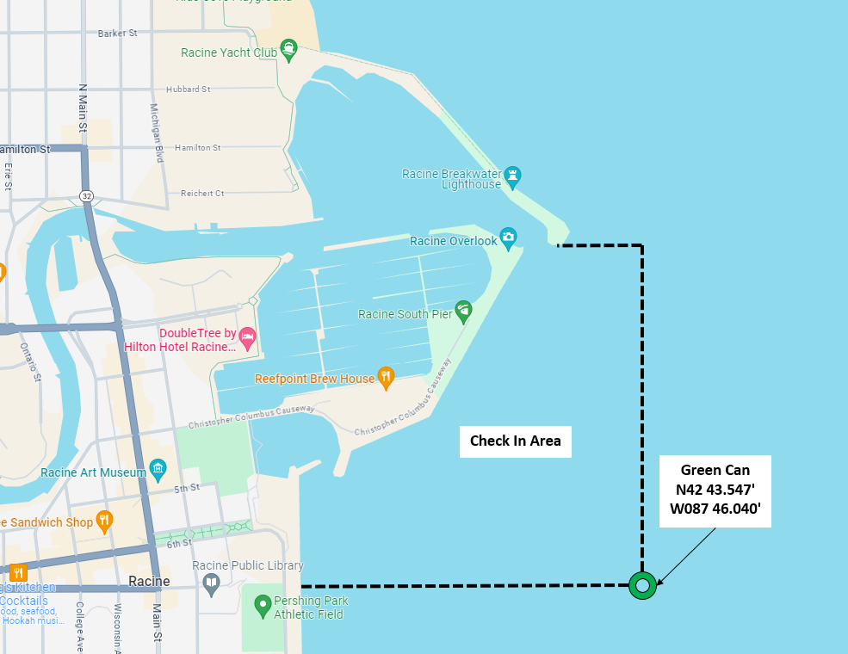Image 1 – Check In Area
g. Each boat must check in with Tournament Control, by VHF radio on channel 68 as they enter the check in area. A tournament boat will be posted near the green can for visual confirmation.
h. Each boat must seal their cooler before it leaves the boat.
i. Each boat must have their boat name on the cooler. The catch log attached to the cooler is acceptable naming of the cooler.
j. A crew member must stay with the cooler until weigh in.
k. The weigh in will be held at the Pershing Park Boat Launch Pavilion. 1 5th St, Racine, WI 53403. See Section 4 for details on weigh in procedure.
l. All coolers must be in the weigh-in line within 30 minutes of the end times listed in section 2C.

4. WEIGH-IN
a. A crew member will disembark with the sealed cooler of fish and signed catch log and proceed directly to the weight station.
b. Once arriving at the weigh station, the cooler must be sealed and remain closed until opened by a Jackpot official.
c. Entrants are responsible for determining what fish will be part of their catch to be weighed. Tournament scales will not be used to sort fish. The first 5 fish on the scales will be the used for the official weight.
5. GENERAL FISHING RULES
a. All fish entered must be caught on hook and line in accordance with the DNR regulations of the state which has jurisdiction over the waters being fished.
b. Any violation of USCG or DNR rules will result in immediate disqualification at the discretion of the Jackpot committee.
c. Each boat is limited to a maximum of nine (9) rods and a three-person limit of fifteen (15) fish, per DNR rules.
d. Each boat may weigh a maximum of five (5) fish, with a maximum of two (2) lake trout.
e. Fish entered for any bonus prizes must be part of the five (5) fish tournament box.
f. Fish may be released when caught. Fish to be released must be returned to the lake immediately.
g. There are no distance limits as to where a tournament boat may fish as long as all traveling is done on the water.
h. All fish kept must be recorded on the catch log.
i. Each boat that reaches the fifteen-fish limit shall immediately cease fishing, bring in all lines, and return to the harbor.
j. No fishing may take place past the first bridge of any harbor or tributary
k. All fishing must be via trolling. No other means are allowed. For example, jigging, casting, or other techniques from a stationary or drifting boat is not permitted.

6. SCORING
a. Winners will be determined on the total accumulation of points. Points will be assigned as ten points per fish and one point per pound.
b. The following species shall be eligible for points: COHO SALMON, CHINOOK SALMON, BROWN TROUT, STEELHEAD OR RAINBOW TROUT, LAKE TROUT and PINK SALMON
c. All winners will be determined by the Tournament Committee, and their decision will be final.
7. PRIZES
a. The top three boats for each individual event will be awarded cash prizes. This will be based on total points for the single event. See section 1b for eligibility.
b. The top three boats for the series will be awarded cash prizes and a trophy per place. This will be based on the sum of the best three points totals from the four single day events. See section 1b for eligibility.
c. The largest fish caught during any of the four individual contest by a boat entered in the series will win a cash prize. See section 1b for eligibility.
d. In case of ties, the boat with biggest fish weighted as part of their tournament catch will win.
- For single day events this will be the biggest fish caught that day.
- For the series it will be biggest fish caught in any of the four events.
e. Participants may win more than one prize.
f. If four events are not able to be completed by using original or rain dates then the prize money for first, second and third for each date not able to be completed will be paid out to three boats drawn randomly for each place.

7. CANCELLATIONS
a. The Tournament Committee will announce their decision if the contest will be run no later than one hour before check in is scheduled to begin. Notification morning of the contest will be made by the tournament committee on VHF marine radio channel 68. If possible, a decision will be made the evening before and communicated via, social media, text, or e-mail as applicable. The Tournament Judges may cancel the Tournament at any time when, in their opinion, the conditions could be dangerous to persons or property.
b. The Tournament Committee may also decide to delay the start of fishing or to cut short the fishing due to deteriorating weather conditions.
c. If there is a small craft advisory, the day will be canceled/postponed/delayed.
d. For rain dates all rules listed for the original contest date apply.
e. In the event that a single day tournament or it associated rain day cannot be run the event will be considered canceled.

8. PROTESTS
a. All protests must be made in writing to the Tournament Committee before 5:00pm on the day of the tournament.
b. Any written protest given to the Tournament Committee must be accompanied by a 100.00 deposit, returnable if the protest is judged valid.
c. A panel of three (3) judges appointed by the Tournament Committee will resolve all disputes.
d. Winners and any person involved in any formal protest may be subject to polygraph testing, prior to the awarding of prizes. Such persons must be available to be tested within 2 weeks of the event.
e. The decision of the Tournament Committee and/or its duly appointed panel of Judges shall be final.

9. RULE CHANGES
a. The Tournament Committee may change or modify any of these rules, as necessary. Any changes will be communicated at the Captain’s Meeting. If changes are made between the original date and rain date they will be communicated via, social media, text, or e-mail as applicable, at the captains meeting and by the tournament committee via VHF radio on channel 68 during check in.
10. LIABILITY EXCLUSION
a. Each contestant shall accept responsibility to protect persons and property from injury or damage during the contest, and Salmon Unlimited of Wisconsin shall not be responsible for the safety of persons or property of participants, regardless of cause.
b. All participants further agree to hold Salmon Unlimited of Wisconsin, its officers, tournament committee, volunteers and sponsors harmless from any liability for damage incurred because of participation in the Tournament, in whatever form or manner said liabilities or damages might be incurred.

